Unpivot :

Reverse the pivot and get original table

1. Create source for pivated dataset

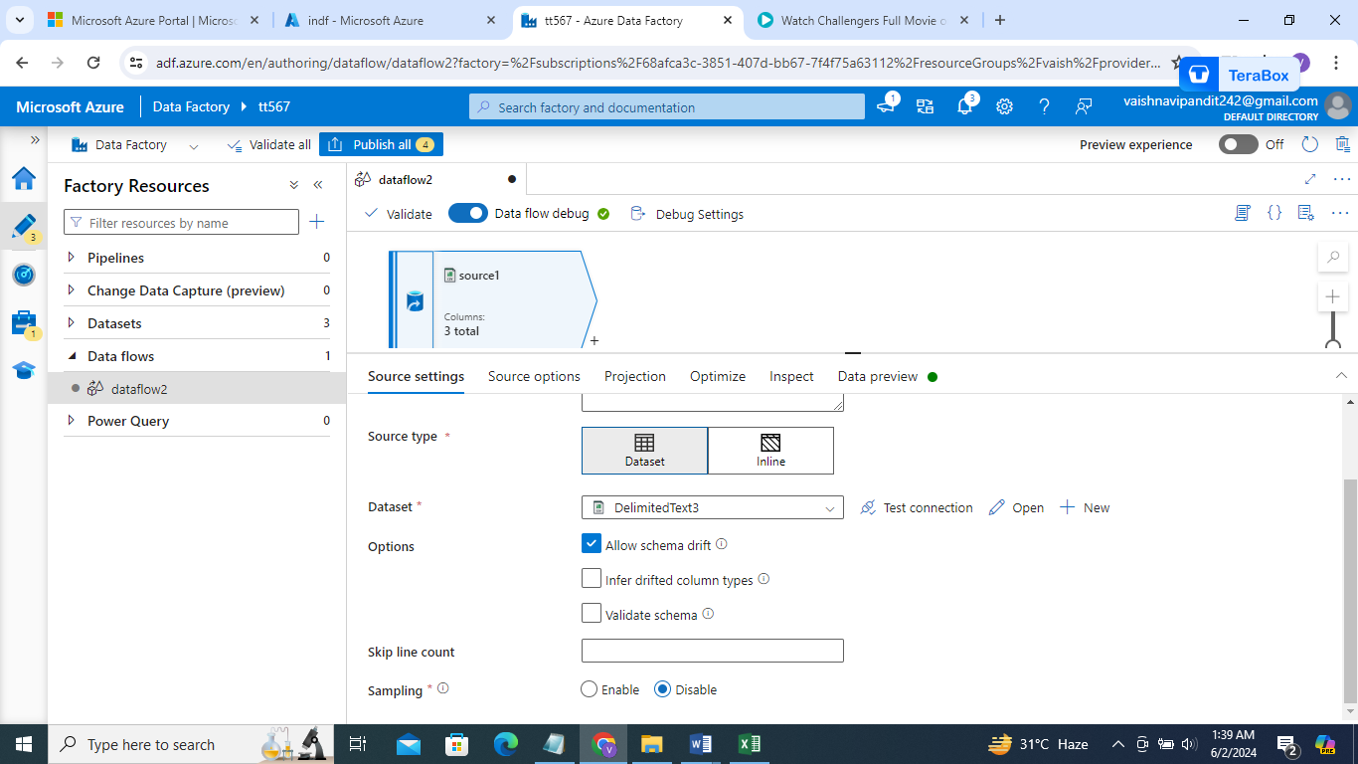

1. Now click plus and select un pivot

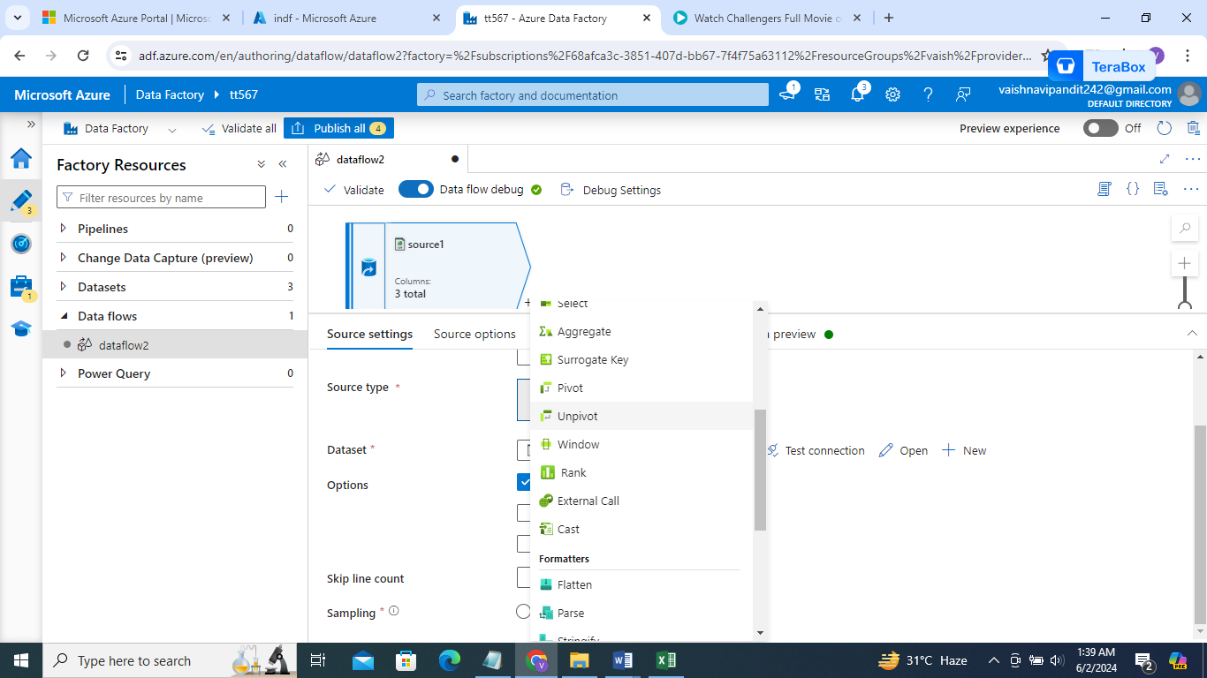

1. Go to unpivot

Ungroup by =deptno

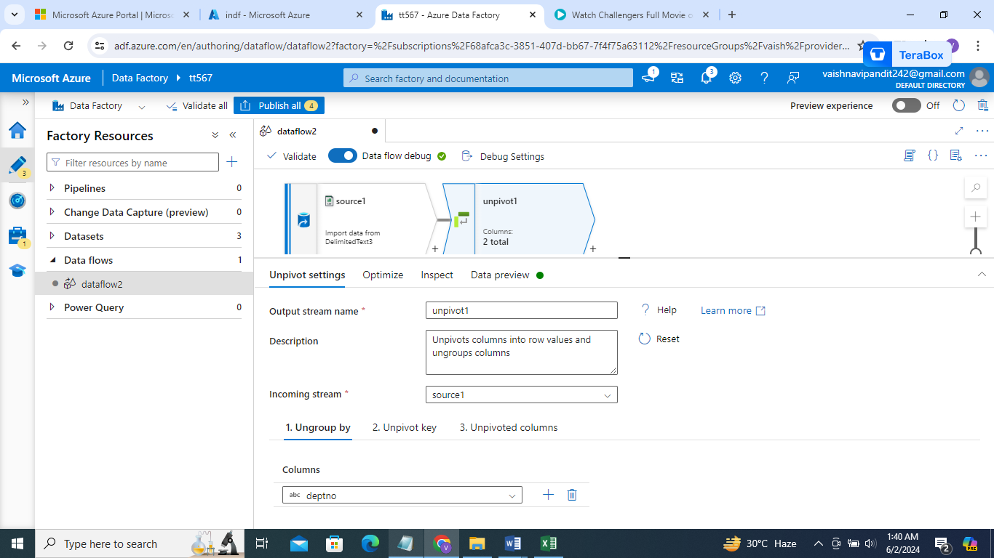

Unpivoted key gender

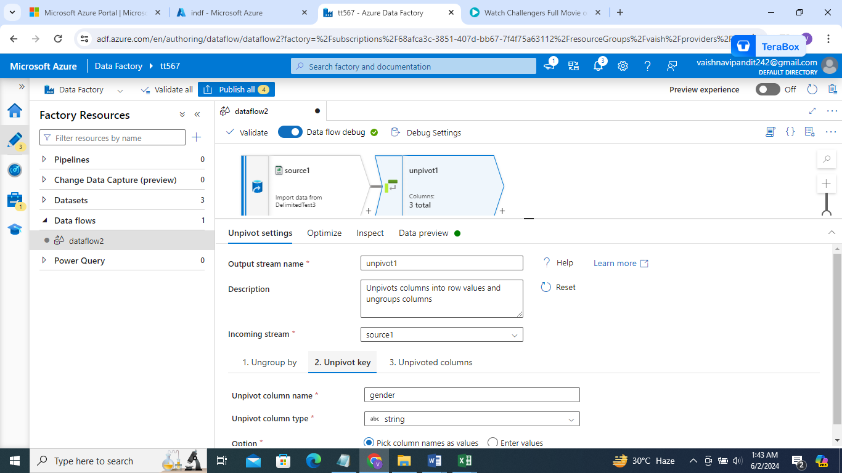

Unpivoted colums =salary

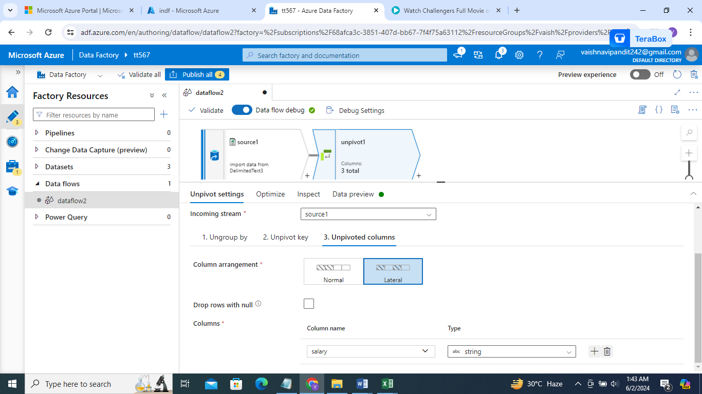

1. Go see preview

